Regulatory Committee
Meeting to be held on 23rd June 2021

Part I

Electoral Division affected:
Mid Rossendale

Wildlife and Countryside Act 1981
Definitive Map Modification Order Investigation
Addition of a Footpath from the junction with Footpath Rawtenstall 206 leading from Hillside Drive to Footpath Rawtenstall 392
(Annex ‘A’ refers)

Contact for further information:
Reference File No. 804-623
Simon Moore, 01772 535604, Paralegal Officer, County Secretary and Solicitors Group, simon.moore@lancashire.gov.uk
Jayne Elliott, 01772 537663, Public Rights of Way Definitive Map Officer, Environment and Planning Group, jayne.elliott@lancashire.gov.uk

Executive Summary

Application for the addition of a Footpath from the junction with Footpath Rawtenstall 206 leading from Hillside Drive, Newchurch to the junction with Footpath Rawtenstall 392 to be added to the Definitive Map and Statement of Public Rights of Way.

Recommendation

That the application for the addition of a public footpath from Footpath

Rawtenstall 206, leading from Hillside Drive, to Footpath Rawtenstall 392 be accepted.

That an Order be made pursuant to Section 53 (2)(b) and Section 53 (3)(b)

and Section 53 (3)(c)(i) of the Wildlife and Countryside Act 1981 to add a Footpath from Footpath Rawtenstall 206 near Hillside Drive to Footpath Rawtenstall 392 on the Definitive Map and Statement of Public Rights of Way as shown on the Committee Plan between points A and B.

That being satisfied that the higher test for confirmation can be met the Order

be promoted to confirmation.

Background

An application under Schedule 14 of the Wildlife and Countryside Act 1981 has been received for the addition of a public footpath on the Definitive Map and Statement on the Definitive Map and Statement of Public Rights of Way from a junction with Footpath Rawtenstall 206 leading from Hillside Drive to a junction with Footpath Rawtenstall 392 leading from Kirkdale Avenue.

The county council is required by law to investigate the evidence and make a decision based on that evidence as to whether a public right of way exists, and if so its status. Section 53(3)(b) and (c) of the Wildlife and Countryside Act 1981 set out the tests that need to be met when reaching a decision; also current Case Law needs to be applied.

An order will only be made to add a public right of way to the Definitive Map and Statement if the evidence shows that:
- A right of way “subsists” or is “reasonably alleged to subsist”

An order for upgrading or downgrading a way shown on the Definitive Map and Statement will only be made if the evidence shows that:
- "it ought to be there shown as a highway of a different description"

An order for adding a way to or upgrading a way shown on the Definitive Map and Statement will be made if the evidence shows that:
- “the expiration… of any period such that the enjoyment by the public…raises a presumption that the way has been dedicated as a public path or restricted byway”

When considering evidence, if it is shown that a highway existed then highway rights continue to exist (“once a highway, always a highway”) even if a route has since become disused or obstructed unless a legal order stopping up or diverting the rights has been made. Section 53 of the Wildlife and Countryside Act 1981 makes it clear that considerations such as suitability, the security of properties and the wishes of adjacent landowners cannot be considered. The Planning Inspectorate’s website also gives guidance about the interpretation of evidence.

The county council’s decision will be based on the interpretation of the evidence discovered by officers and documents and other evidence supplied by the applicant, landowners, consultees and other interested parties produced to the county council before the date of the decision. Each piece of evidence will be tested and the evidence overall weighed on the balance of probabilities. It is possible that the council’s decision may be different from the status given in any original application. The decision may be that the routes have public rights as a footpath, bridleway, restricted byway or byway open to all traffic, or that no such right of way exists. The decision may also be that the routes to be added or deleted vary in length or location from those that were originally considered.

Consultations

Rossendale Borough Council

No information was provided by Rossendale Borough Council in response to our consultation.

Applicant/Landowners/Supporters/Objectors

The evidence submitted by the applicant/landowners/supporters/objectors and observations on those comments are included in Advice – Head of Service – Legal and Democratic Services Observations.

Advice

Head of Service – Planning and Environment

Points annotated on the attached Committee plan.

Point | Grid Reference (SD) | Description
A | 8327 2251 | Junction with Footpath Rawtenstall 206 at northern entrance to Home Farm
B | 8331 2251 | Junction with Footpath Rawtenstall 392

Description of Route

A site inspection was carried out in 2019.

The application route commences at point A on the Committee on Footpath Rawtenstall 392 which runs from Kirkdale Avenue immediately to the east of the boundary of Home Farm. From point A it crosses a stone stile constructed in a wall and then continues in a westerly direction for a distance of approximately 35 metres to point B. It is bounded on both sides – to the south by fencing and building forming part of Home Farm and to the north by garden fences separating it from 16 and 18 Hillside Drive. The route varies in width between 1 metre and 1.5 metres and appeared to have been surfaced with compacted stone at some point in the past (although this was now largely covered).

When inspected in 2019 there was evidence that the route was being used and that vegetation overhanging the route close to point B had been recently cut.

Map and Documentary Evidence

A variety of maps, plans and other documents were examined to discover when the route came into being, and to try to determine what its status may be.

Document Title | Date | Brief Description of Document & Nature of Evidence
Yates’ Map  of Lancashire | 1786 | Small scale commercial map. Such maps were on sale to the public and hence to be of use to their customers the routes shown had to be available for the public to use. However, they were privately produced without a known system of consultation or checking. Limitations of scale also constrained the routes that could be shown.

Observations |  | The application route is not shown.
Investigating Officer's Comments |  | The route did not exist as major route at the time although it may have existed as a minor route which would not have been shown due to the limitations of scale so no inference can be drawn in this respect.
Honour of Clitheroe Map | 1804-1810 | A privately produced map of land owned by the Honour of Clitheroe – Henry Duke of Buccleuth and Elizabeth Duchess of Buccleuth. It specifically shows the boundaries of coal leases granted by them. 'Roads' were identified in the key but there was no apparent distinction between those which may have been considered to be public or private.
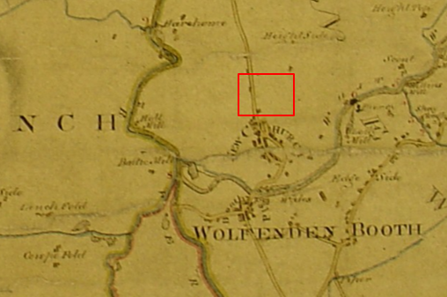
Observations |  | The application route is not shown.
Investigating Officer's Comments |  | The route did not exist as major route at the time although it may have existed as a minor route which would not have been shown due to the limitations of scale so no inference can be drawn in this respect.
Greenwood’s Map of Lancashire | 1818 | Small scale commercial map. In contrast to other map makers of the era Greenwood stated in the legend that this map showed private as well as public roads and the two were not differentiated between within the key panel.
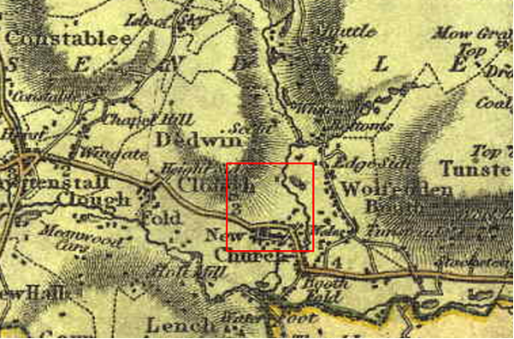
Observations |  | The application route is not shown.
Investigating Officer's Comments |  | The route did not exist as major route at the time although it may have existed as a minor route which would not have been shown due to the limitations of scale so no inference can be drawn in this respect.
Hennet's Map of Lancashire | 1830 | Small scale commercial map. In 1830 Henry Teesdale of London published George Hennet's Map of Lancashire surveyed in 1828-1829 at a scale of 71/2 inches to 1 mile. Hennet's finer hachuring was no more successful than Greenwood's in portraying Lancashire's hills and valleys but his mapping of the county's communications network was generally considered to be the clearest and most helpful that had yet been achieved.
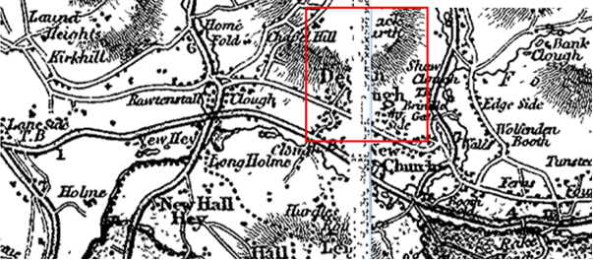
Observations |  | The application route is not shown.
Investigating Officer's Comments |  | The route did not exist as major route at the time although it may have existed as a minor route which would not have been shown due to the limitations of scale so no inference can be drawn in this respect.
Canal and Railway Acts |  | Canals and railways were the vital infrastructure for a modernising economy and hence, like motorways and high speed rail links today, legislation enabled these to be built by compulsion where agreement couldn't be reached. It was important to get the details right by making provision for any public rights of way to avoid objections but not to provide expensive crossings unless they really were public rights of way. This information is also often available for proposed canals and railways which were never built.
Observations |  | There are no existing, dismantled or proposed railways or canals crossing the land over which the application route runs.
Investigating Officer's Comments |  | No inference can be drawn.
Tithe Map and Tithe Award or Apportionment |  | Maps and other documents were produced under the Tithe Commutation Act of 1836 to record land capable of producing a crop and what each landowner should pay in lieu of tithes to the church. The maps are usually detailed large scale maps of a parish and while they were not produced specifically to show roads or public rights of way, the maps do show roads quite accurately and can provide useful supporting evidence (in conjunction with the written tithe award) and additional information from which the status of ways may be inferred.
Observations |  | There is no Tithe Map or Award for the area crossed by the application route
Investigating Officer's Comments |  | No inference can be drawn.
Inclosure Act Award and Maps |  | Inclosure Awards are legal documents made under private acts of Parliament or general acts (post 1801) for reforming medieval farming practices, and also enabled new rights of way layouts in a parish to be made. They can provide conclusive evidence of status.
Observations |  | There is no Inclosure Award for the area crossed by the application route.
Investigating Officer's Comments |  | No inference can be drawn.
6 Inch Ordnance Survey (OS) Map Sheet 72 | 1849 | The earliest Ordnance Survey 6 inch map for this area surveyed in 1844-47 and published in 1849.
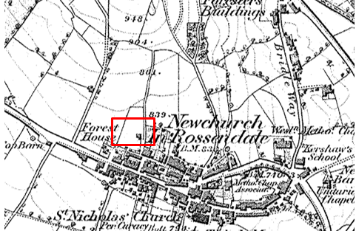
Observations |  | A building is shown in proximity of Home Farm and Footpath Rawtenstall 392 (which the application route meets at point B) are shown but the application route itself is not shown.
Investigating Officer's Comments |  | The application route did not exist in 1844-47.
Cassini Map Old Series | 1842-4 | The Cassini publishing company produced maps based on Ordnance Survey mapping. These maps have been enlarged and reproduced to match the modern day 1:50, 000 OS Landranger Maps and are readily available to purchase.
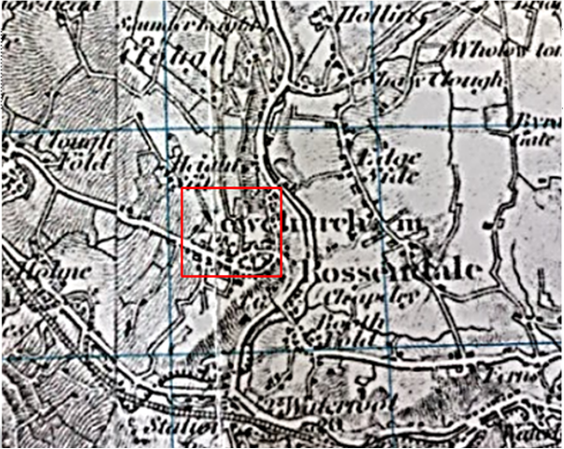
Observations |  | The application route does not appear to be shown on this small scale map.
Investigating Officer's Comments |  | The original scale of the map (1 inch to the mile) means that only the more substantial routes are generally shown. The purpose of the map in the late 1800s would probably have been to assist the travelling public on horseback or vehicle suggesting that the through roads shown had public rights for those travellers. This map is dated as being published around the same time as the first edition 6 inch map detailed above was surveyed. Taking into consideration other OS maps published at this time – and after – it appears that the application route did not exist at this time.
25 Inch OS Map  Sheet 72-10 | 1891 | The earliest OS map at a scale of 25 inch to the mile. Surveyed and published in 1891.
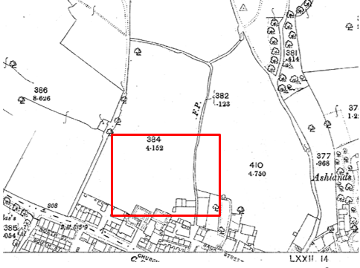
Observations |  | The application route is not shown.
Investigating Officer's Comments |  | The application route did not exist in 1891.
1 inch OS Map of Rochdale (Sheet 76) | 1896 | 1 inch Ordnance Survey map published 1896.
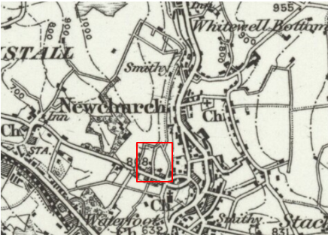
Observations |  | The application route is not shown.
Investigating Officer's Comments |  | The application route did not exist in 1896 or was too minor to be recorded at this scale.
25 inch OS Map  Sheet 72-10 | 1911 | Further edition of the 25 inch map re-surveyed in 1891, revised in 1908 and published in 1911.
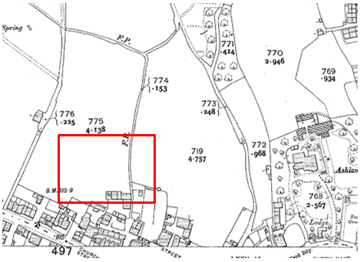
Observations |  | The application route is not shown.
Investigating Officer's Comments |  | The application route did not exist in 1908.
Bartholomew half inch Mapping | 1902-1906 | The publication of Bartholomew's half inch maps for England and Wales began in 1897 and continued with periodic revisions until 1975. The maps were very popular with the public and sold in their millions, due largely to their accurate road classification and the use of layer colouring to depict contours. The maps were produced primarily for the purpose of driving and cycling and the firm was in competition with the Ordnance Survey, from whose maps Bartholomew's were reduced. An unpublished Ordnance Survey report dated 1914 acknowledged that the road classification on the OS small scale map was inferior to Bartholomew at that time for the use of motorists.
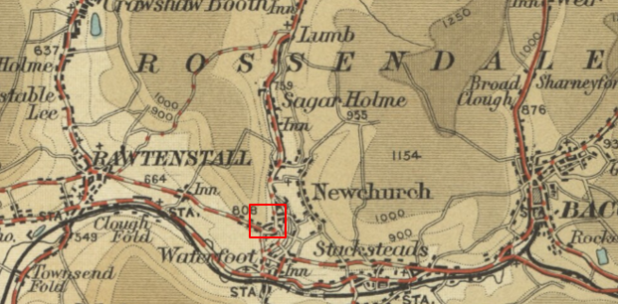
Observations |  | The application route is not shown.
Investigating Officer's Comments |  | The application route did not exist in 1902-1906 or was too minor to be shown on a map at this scale.
Finance Act 1910 Map | 1910 | The comprehensive survey carried out for the Finance Act 1910, later repealed, was for the purposes of land valuation not recording public rights of way but can often provide very good evidence. Making a false claim for a deduction was an offence although a deduction did not have to be claimed so although there was a financial incentive a public right of way did not have to be admitted.  Maps, valuation books and field books produced under the requirements of the 1910 Finance Act have been examined. The Act required all land in private ownership to be recorded so that it could be valued and the owner taxed on any incremental value if the land was subsequently sold. The maps show land divided into parcels on which tax was levied, and accompanying valuation books provide details of the value of each parcel of land, along with the name of the owner and tenant (where applicable).  An owner of land could claim a reduction in tax if his land was crossed by a public right of way and this can be found in the relevant valuation book. However, the exact route of the right of way was not recorded in the book or on the accompanying map. Where only one path was shown by the Ordnance Survey through the landholding, it is likely that the path shown is the one referred to, but we cannot be certain. In the case where many paths are shown, it is not possible to know which path or paths the valuation book entry refers to. It should also be noted that if no reduction was claimed this does not necessarily mean that no right of way existed.
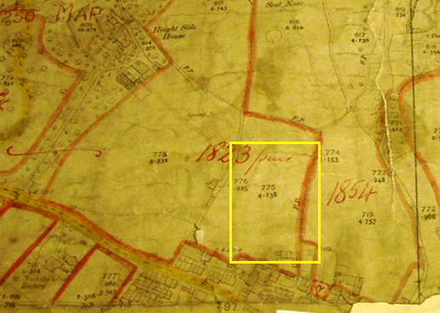
Map deposited at The National Archives
Observations |  | There is no Finance Act Map deposited in the County Records Office but the map deposited in The National Archives was obtained. The application route is not shown on the OS base map used to prepare the Finance Act map and the land crossed by the route is included in the plot numbered 1823.  The District Valuation Book was inspected in the County Archives which lists plot 1823 as being owned by HH Bolton, Higbrake, Accrington and described simply as 'land' with no deductions listed for public rights of way or user.
Investigating Officer's Comments |  | The landowner did not appear to acknowledge the existence of a public right of way across the land over which the application route runs when the 1910 valuation was carried out.
25 Inch OS Map | 1930 | Further edition of 25 inch map (re-surveyed 1891, revised in 1928 and published in 1930.
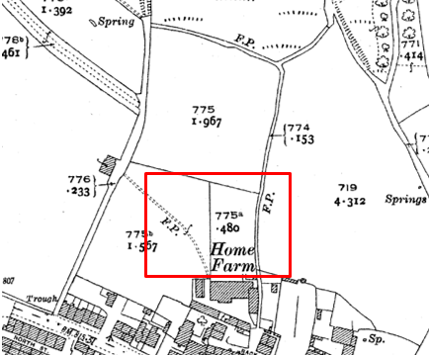
Observations |  | The application route is not shown. A double pecked path with the notation 'F.P' (Footpath) is shown leading to Point A at the entrance to Home Farm.
Investigating Officer's Comments |  | The application route did not exist in 1928.
Authentic Map Directory of South Lancashire by Geographia | Circa1934 | An independently produced A-Z atlas of Central and South Lancashire published to meet the demand for such a large-scale, detailed street map in the area. The Atlas consisted of a large scale coloured street plan of South Lancashire and included a complete index to streets which includes every 'thoroughfare' named on the map.  The introduction to the atlas states that the publishers gratefully acknowledge the assistance of the various municipal and district surveyors who helped incorporate all new street and trunk roads. The scale selected had enabled them to name 'all but the small, less-important thoroughfares'.
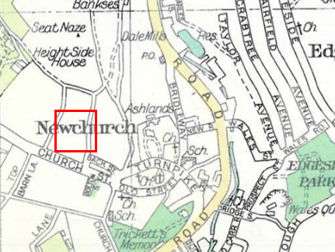
Observations |  | The application route is not shown.
Investigating Officer's Comments |  | The application route did not exist in the 1930s.
Aerial Photograph | 1940s | The earliest set of aerial photographs available was taken just after the Second World War in the 1940s and can be viewed on GIS. The clarity is generally very variable.
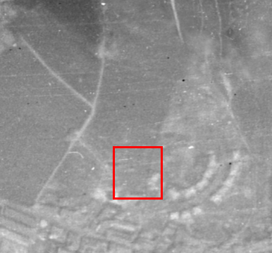
Observations |  | The quality of the aerial photograph is poor and it is not possible to identify physical features in the proximity of the application route.
Investigating Officer's Comments |  | No inference can be drawn.
6 Inch OS Map  Sheet 82SW | 1956 | The OS base map for the Definitive Map, First Review, was published in 1956 at a scale of 6 inches to 1 mile (1:10,560). This map was revised before 1930 but was also stated to have been revised for major changes in 1950 and is probably based on the same survey as the 1930s 25-inch map.
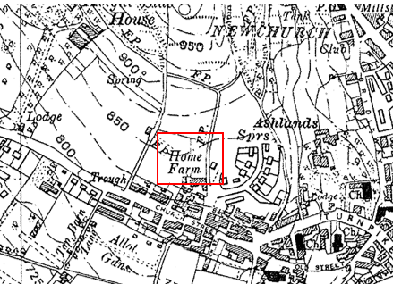
Observations |  | The application route is not shown.
Investigating Officer's Comments |  | The application route did not exist in the 1920s when the area shown on the map was surveyed.
1:2500 OS Map | 1962 | Further edition of 25 inch map reconstituted from former county series and revised in 1960 and published in 1962 as national grid series.
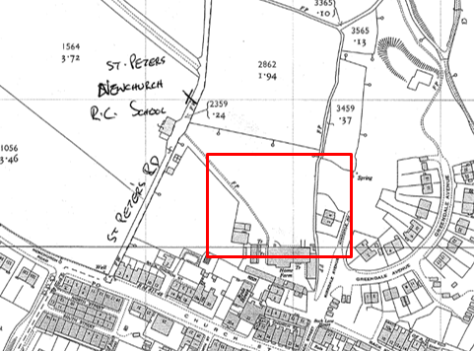
Observations |  | The application route is not shown.
Investigating Officer's Comments |  | The application route did not exist in 1960 when the map was surveyed.
Aerial photograph | 1960s | The black and white aerial photograph taken in the 1960s and available to view on GIS.
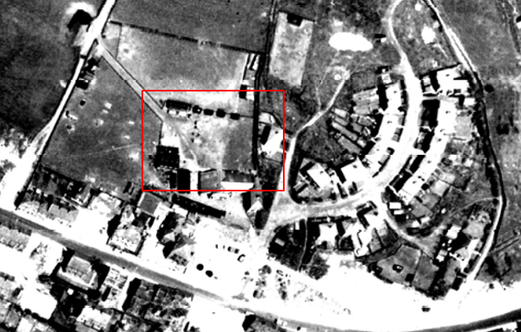
Observations |  | The application route is not visible.
Investigating Officer's Comments |  | The application route probably did not exist in the 1960s.
Aerial Photograph | 2000 | Aerial photograph available to view on GIS.
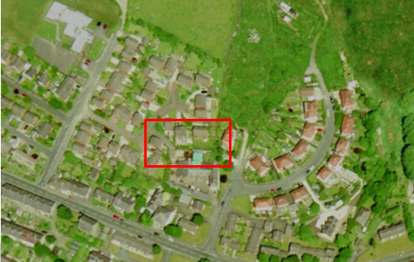
Observations |  | The scale of the photograph, shadows and tree cover make it impossible to confirm the existence of the application route. However, the aerial photograph shows that the houses on Hillside Drive had been built at that time.
Investigating Officer's Comments |  | No inference can be drawn.
Aerial Photograph | 2014 | Aerial photograph available to view on GIS.
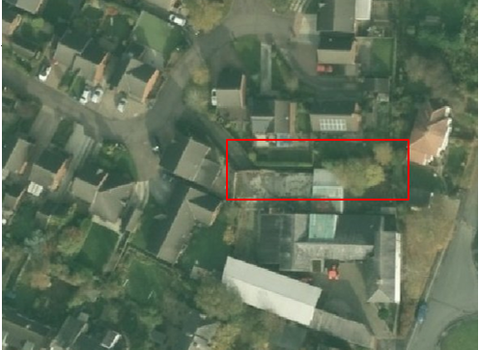
Observations |  | Part of the application route between point A and point B can be seen on the photograph although the remainder of the route (approaching point B) is obscured by tree cover).
Investigating Officer's Comments |  | The application route probably existed in 2014.
Definitive Map Records |  | The National Parks and Access to the Countryside Act 1949 required the County Council to prepare a Definitive Map and Statement of Public Rights of Way.  Records were searched in the Lancashire Records Office to find any correspondence concerning the preparation of the Definitive Map in the early 1950s.
Parish Survey Map | 1950-1952 | The initial survey of public rights of way was carried out by the parish council in those areas formerly comprising a rural district council area and by an urban district or municipal borough council in their respective areas. Following completion of the survey the maps and schedules were submitted to the County Council. In the case of municipal boroughs and urban districts the map and schedule produced, was used, without alteration, as the Draft Map and Statement. In the case of parish council survey maps, the information contained therein was reproduced by the County Council on maps covering the whole of a rural district council area. Survey cards, often containing considerable detail exist for most parishes but not for unparished areas.
Observations |  | The application route is within Rawtenstall which was a municipal borough in the early 1950s so a parish survey map was not compiled.
Draft Map |  | The Draft Maps were given a “relevant date” (1st January 1953) and notice was published that the draft map for Lancashire had been prepared. The draft map was placed on deposit for a minimum period of 4 months on 1st January 1955 for the public, including landowners, to inspect them and report any omissions or other mistakes. Hearings were held into these objections, and recommendations made to accept or reject them on the evidence presented.
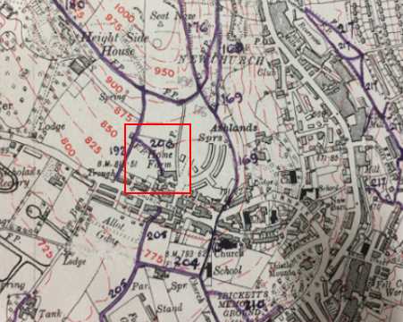
Observations |  | The application route was not shown on the Draft Map and no objections or representations were made to the county council about it.
Provisional Map |  | Once all representations relating to the publication of the draft map were resolved, the amended Draft Map became the Provisional Map which was published in 1960, and was available for 28 days for inspection. At this stage, only landowners, lessees and tenants could apply for amendments to the map, but the public could not. Objections by this stage had to be made to the Crown Court.
Observations |  | The application route was not shown on the Provisional Map and no objections or representations were made to the county council about it.
The First Definitive Map and Statement |  | The Provisional Map, as amended, was published as the Definitive Map in 1962.
Observations |  | The application route was not shown on the First Definitive Map.
Revised Definitive Map of Public Rights of Way (First Review) |  | Legislation required that the Definitive Map be reviewed, and legal changes such as diversion orders, extinguishment orders and creation orders be incorporated into a Definitive Map First Review. On 25th April 1975 (except in small areas of the County) the Revised Definitive Map of Public Rights of Way (First Review) was published with a relevant date of 1st September 1966. No further reviews of the Definitive Map have been carried out. However, since the coming into operation of the Wildlife and Countryside Act 1981, the Definitive Map has been subject to a continuous review process.
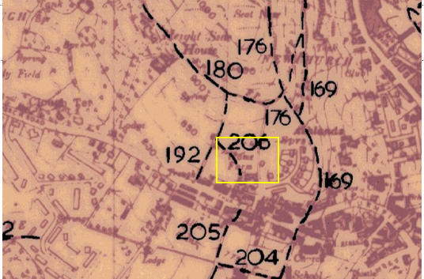
Observations |  | The application route is not recorded on the Revised Definitive Map (First Review).
Investigating Officer's Comments |  | From 1953 through to 1975 there is no indication that the application route was considered to be a public right of way of the type to be recorded on the Definitive Map and Statement by the Surveying Authority. There were no objections or representations made with regard to the fact that the route was not shown on the map when the maps were placed on deposit for inspection or at any stage of the preparation of the Definitive Map.
Highway Adoption Records including maps derived from the '1929 Handover Maps' | 1929 to present day | In 1929 the responsibility for district highways passed from district and borough councils to the County Council. For the purposes of the transfer, public highway 'handover' maps were drawn up to identify all of the public highways within the county. These were based on existing Ordnance Survey maps and edited to mark those routes that were public. However, they suffered from several flaws – most particularly, if a right of way was not surfaced it was often not recorded.  A right of way marked on the map is good evidence but many public highways that existed both before and after the handover are not marked. In addition, the handover maps did not have the benefit of any sort of public consultation or scrutiny which may have picked up mistakes or omissions.  The County Council is now required to maintain, under section 31 of the Highways Act 1980, an up to date List of Streets showing which 'streets' are maintained at the public's expense. Whether a road is maintainable at public expense or not does not determine whether it is a highway or not.
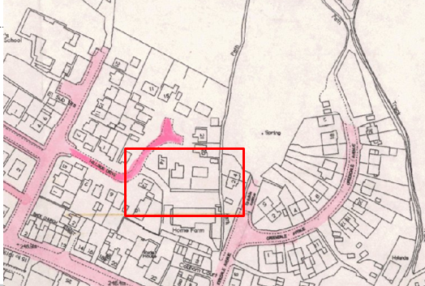
Observations |  | The application route is not recorded as a publicly maintainable highway on the county council's List of Streets.
Investigating Officer's Comments |  | The fact that the route is not recorded as a publicly maintainable highway does not mean that it does not carry public rights of access.
Diversion of Footpath Rawtenstall 206 | 1986 | Diversion order made and confirmed by Rossendale Borough Council in 1986.
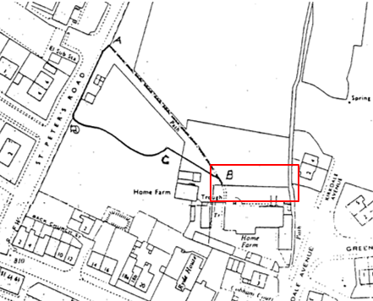
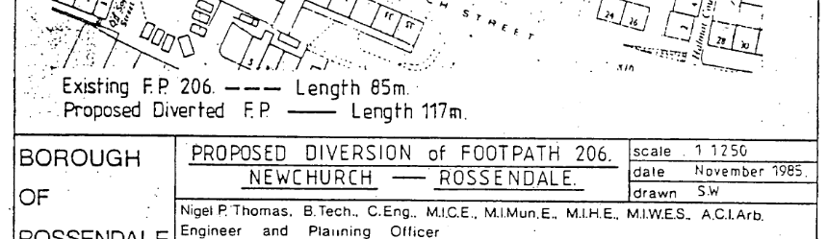
Extract from Diversion Order
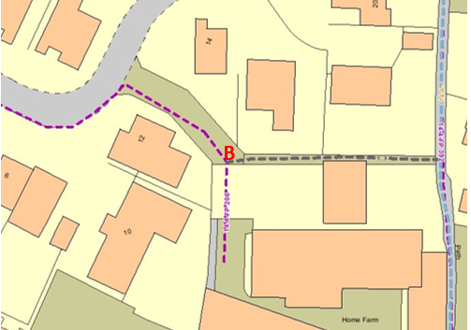
Plan showing the diverted route of Footpath 206 leading into the farmyard
Observations |  | In 1986 Footpath Rawtenstall 206 was diverted by Rossendale Borough Council to enable development to be carried out in accordance with planning permission. The development referred to was the construction of residential properties on Hillside Drive. The Diversion Order diverted part of the route of Footpath 206 to run along the estate road subsequently built as part of the development (Hillside Drive) and the access track leading directly into the farm from the north. The application route is not shown on the Order plan or referred to as being constructed as part of the diversion. The route of Footpath 206 is shown leading to the entrance of the farm (point B on the Committee plan) but the continuation of the path into the farmyard is not shown as this was unaffected by the Diversion Order.
Investigating Officer's Comments |  | The Diversion Order dates the starting point for the residential development of the land north of the application route. The Order plan does not show the application route existing in 1986 and there is no reference to any proposal to construct the route as part of the development and diversion of Footpath 206. It should be noted however that Footpath 206 continues south from point B (on the Committee plan) for approximately 15 metres into the farmyard where it is recorded as ending/starting 'From N. side of Home Farm' on the Definitive Statement.
Land Registry Plans | 1987 | OS 1:1250 scale base maps used for land registry plans.
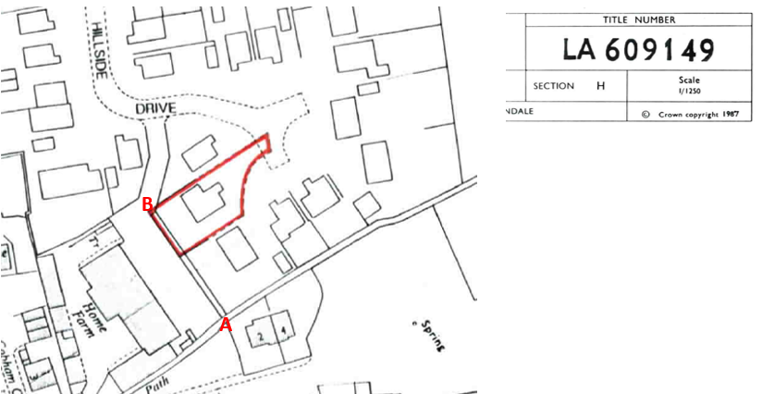
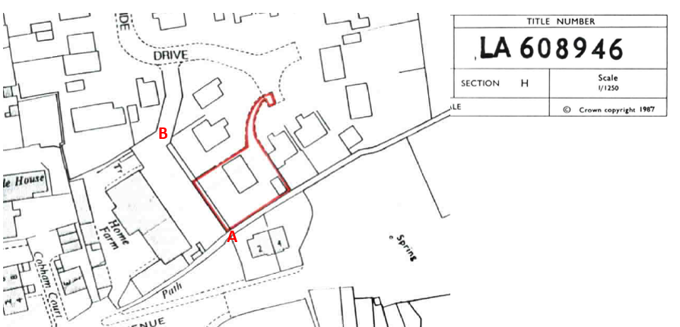
Observations |  | The plans are dated 1987 and show that by that date the properties on Hillside Drive had been built. They are the earliest maps found to show the application route although it is noted that the route is contained within fence lines next to the boundaries of the two properties and that on the OS base map used the application route is shown with lines across it at both point A and point B.
Investigating Officer's Comments |  | The application route existed in 1987. Access may have been restricted at point A and point B – the line across the route at point A being consistent with the existing stone stile located at that point today.
Planning Application for the development | 1986/7 | Planning application documents were sought from Rossendale Council but were not available. How the application route is shown is not known.
Statutory deposit and declaration made under section 31(6) Highways Act 1980 |  | The owner of land may at any time deposit with the County Council a map and statement indicating what (if any) ways over the land he admits to having been dedicated as highways. A statutory declaration may then be made by that landowner or by his successors in title within ten years from the date of the deposit (or within ten years from the date on which any previous declaration was last lodged) affording protection to a landowner against a claim being made for a public right of way on the basis of future use (always provided that there is no other evidence of an intention to dedicate a public right of way).  Depositing a map, statement and declaration does not take away any rights which have already been established through past use. However, depositing the documents will immediately fix a point at which any unacknowledged rights are brought into question. The onus will then be on anyone claiming that a right of way exists to demonstrate that it has already been established. Under deemed statutory dedication the 20 year period would thus be counted back from the date of the declaration (or from any earlier act that effectively brought the status of the route into question).
Observations |  | No Highways Act 1980 Section 31(6) deposits have been lodged with the county council for the area over which the route under investigation runs.
Investigating Officer's Comments |  | There is no indication by the landowners under this provision of non-intention to dedicate public rights of way over this land.

The affected land is not designated as access land under the Countryside and Rights of Way Act 2000 and is not registered common land.

Landownership

At point B the route crosses a small section of title number LA634638. The remainder of the application route crosses two further plots. These plots form part the freehold and leasehold titles of the adjoining properties. The leaseholder of one of the lengths, LA608946, has provided a user evidence form detailing use of the whole length of the application route.

The land registry titles show that a developer company purchased the farmland in 1986. Long leaseholds were granted by the developer a few years later. The developer's freehold title is now held by a large company.

Summary

There is no map or documentary evidence to suggest that the route under investigation existed before the housing development was built.

The first map to show the route was dated 1987 and although lines are shown across it at point A and point B this does not necessarily mean that access was not available given the information on site of the stile and estate layout.

The application is based on user evidence which is supported by the map and photographic evidence post 1987 and the Investigating Officer found nothing to suggest that the route could not – or was not in use throughout the years referred to in the user evidence.

Head of Service – Legal and Democratic Services Observations

Information from the Applicant

The Applicant provided the following supporting information:

- A map extract from the 1966 Definitive Map.
- A Map showing application route highlighted yellow.
- 9 Public Right of Way User Evidence Statements, a summary of which is provided below.

Duration of Use

The user evidence forms collectively provide evidence of use going back as far as 1972 and up to 2020 when the application to record the right of way was made.

20+ Years  Including the years (2000 to 2020) | 1-19 Years
7 | 2

Frequency of Use

The Committee should note that the use evidenced by a long leaseholder of a significant part of the route needs careful consideration as their use may not be "as of right. The majority of the users stated that they used the route weekly or daily with one noting use monthly.

Daily | Multiple times each week | Weekly | Monthly
2 | 2 | 5 | 1

Reasons for Use

All users recorded use of the route on foot. The specified reasons for using the route included access to other parts of the village/community, pleasure and access to the local footpath network. One user specified dog walking and one user specified using the route to take their children to school.

Other Users of the Route

All nine users noted seeing others using the route on foot, with some specifying use to access other parts of the village and children using the route to get to school. Regular use by locals was noted.

Consistency of the Route

All but one of the nine users stated that the route had remained consistent; the one user who did not specified that they did not know due to being new to the area. The width of the route was generally stated to be between 1 and 1.5 metres with one user specifying a width of 3 feet and another specifying 2 yards.

Unobstructed Use of the Route

None of the users recalled being obstructed from using the route; all but one did not recall any signs or notices along the route with one stating that they did not know. Three of the users noted a stile along the route whilst the remaining six did not, this stile is present at the eastern end of the route where it meets footpath 14-4-FP 392. One user noted a step for access.

Information from Others

No further information was provided by other consultees, those responses received simply stated the respondents lack of objection to the application.

Information from the Landowners

Only one of the landowners responded to the consultation, simply returning the consultation plan shaded to confirm landownership. This long leaseholder had already provided further information in the form of a Public Right of Way User Evidence Statement submitted with the application.

Assessment of the Evidence

The Law - See Annex 'A'

In Support of Making an Order(s)

- User evidence forms
- Evidence of seeing other users
- Physical route fenced out from land used by private residents
- Absence of notices/signs along the route stating the route was not public
- Landowners taking no action against public use

Against Making an Order(s)

- None

Conclusion

There is no evidence of an express dedication and therefore Committee is invited to consider whether a dedication of public footpath rights can be inferred, on balance, from all the circumstances at common law or deemed under s.31 Highways Act 1980.

Looking firstly at whether dedication can be inferred at common law. Committee is advised to consider whether evidence from the Old County maps and other documentary evidence coupled with the evidence on site and all circumstances together with user evidence which here does on balance indicate that the route should be recorded as having achieved footpath status in law. The Head of Service - Planning and Environment has considered the historical map evidence.

The historical map evidence evaluated within the report demonstrates the route is unlikely to have been in existence prior to 1960. Land Registry Title plans dated 1987 are the first plans to show the application route and confirm that at this time the houses on Hillside Drive had been built, aerial photographs from 2000 also confirm the properties were built on Hillside Drive, the aerial photographs of 2014 depict part of the route, the whole route is not visible and this may be due to tree coverage. The officer concludes the documentary evidence shows that application route is likely to have existed in by 1987.

On balance, the historical map and documentary evidence on its own is considered to be insufficient to conclude the route was a historical public footpath and it is therefore necessary to consider the user evidence and other circumstances in that context. It was noted that there was a stile on the route to facilitate access and as of right use evidenced by 7 statements goes back to, in 1 case, 1972. The developer acquired the farmland in 1986 and the route was physically created between fencelines leading to the stile. It is suggested to committee that the creation of the route by the owner and then the use by the public is of sufficient quantity and quality from which dedication can on balance be inferred.

Committee is also advised to consider whether deemed dedication under S.31 Highways Act 1980 can be satisfied. Committee will be aware that in order to satisfy the criteria of S.31, there must be sufficient evidence of use of the application route by the public, as of right and without interruption, over the twenty-year period immediately prior to its status being brought into question, in order to raise a presumption of dedication. This presumption may be rebutted if there is sufficient evidence that there was no intention on the part of the landowner during this period to dedicate the route as a public right of way.

In support of the application, 9 user evidence forms have been submitted. Care has to be taken regarding the evidence from owners of part of the route. The evidence displays use of the route from 1972 until 2020, when the application was made to the Authority. There does not appear to have been any event prior to 2020 which brought the route into question, therefore the making of the application on 13th May 2020 is when the route was brought into question and the 20 year relevant period is calculated retrospectively from this date, the relevant period under consideration is therefore 2000-2020.

The majority of the users claim to have used the route on a daily or weekly basis. Most of the users claim to have used the route for over 20 years which includes the relevant period. None of the users recall having seen any signs or notices preventing them from using the route. A stile across the route is noted by the users but no users report any obstructions which prevented them from using the route. No user reports having ever sought permission to use the route, one of the landowners across the route has also completed a user evidence form in support of the application. Therefore, on balance it is reasonable to conclude the route was used by the pubic and use has been as of right with any interruption. We must also consider the intentions of the land owner during the relevant period and it seem there has been no overt action taken by land owners with one land owner in support of the route having completed a user form, no other landowners have expressed any objections to the application.

In conclusion, it is recommended that Committee accept the application as on balance deemed dedication under s.31 can be satisfied or dedication inferred from all the circumstances including the use and an Order be made.

Risk management

Consideration has been given to the risk management implications associated with this claim. The Committee is advised that the decision taken must be based solely on the evidence contained within the report, and on the guidance contained both in the report and within Annex 'A' included in the Agenda Papers. Provided any decision is taken strictly in accordance with the above then there is no significant risks associated with the decision making process.

Local Government (Access to Information) Act 1985

List of Background Papers

Paper | Date | Contact/Directorate/Tel
All documents on File Ref: 804-623 |  | Simon Moore, 01772 531280, County Secretary and Solicitors Group
Reason for inclusion in Part II, if appropriate

N/A

The Ordnance Survey (OS) has produced topographic maps at different scales (historically one inch to one mile, six inches to one mile and 1:2500 scale which is approximately 25 inches to one mile). Ordnance Survey mapping began in Lancashire in the late 1830s with the 6-inch maps being published in the 1840s. The large scale 25-inch maps which were first published in the 1890s provide good evidence of the position of routes at the time of survey and of the position of buildings and other structures. They generally do not provide evidence of the legal status of routes, and carry a disclaimer that the depiction of a path or track is no evidence of the existence of a public right of way.
Aerial photographs can show the existence of paths and tracks, especially across open areas, and changes to buildings and field boundaries for example. Sometimes it is not possible to enlarge the photos and retain their clarity, and there can also be problems with trees and shadows obscuring relevant features.

